The rights are:
Privacy Information for Children and Young People

- Know what is happening with your information
- Ask to see or have a copy of your information
- Ask for some of your information to be changed
- Ask us to delete your information
- Ask us to stop using your information for a little bit
- Ask for your information to be transferred to another organisation
- Ask us to stop using your information

Dependent on the situation and the circumstances involved, there may be some rights which do not apply. If this is the case, we will explain why.
Any Questions?
If you have any questions or want any further information, then you can ask a member of staff at the Practice, this could be anyone from a receptionist to your doctor.
If you want to use the rights available to you, access any of your records or make a complaint you can contact:

Practice Manager | Enquiries.w93061@wales.nhs.uk
IG Lead | Enquiries.w93061@wales.nhs.uk
Data Protection Officer | DHCWGMPDPO@wales.nhs.uk
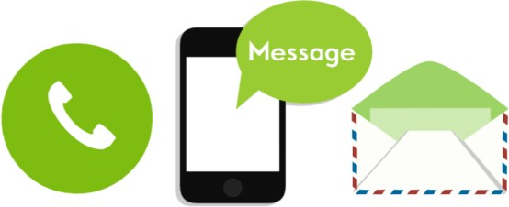

Version 1 Last Reviewed: 20th February 2024

Introduction

When you are a patient with the Practice, we will need to keep some information about you to give you the best care and treatment. This leaflet will help you understand what information. The Rogerstone Practice collects about you and how we keep this information safe.
What information do we collect?
- Name
- Address
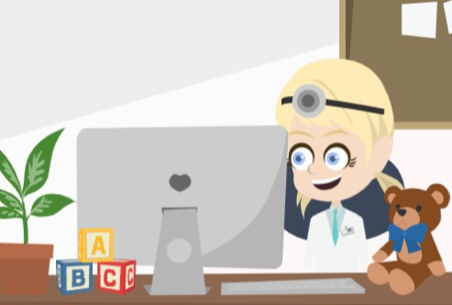
- Date of Birth
- Name of the person that brings you to appointments
- Information provided by you, your family and any other health care professional
- Hospital visits and treatments
- The reason you are coming to see us and what we do to care for you

Why we collect your information?
How do we keep your records safe?

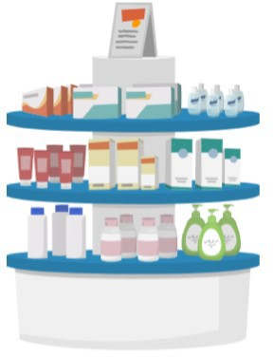
The Practice’s purpose is to deliver healthcare to everyone. We collect the data we need to care for you in the best way.
  - We ask for your address so that we know where we can contact you.
  - We ask for your date of birth as your age may be important to your care.
Each time you come to see us we make a note of what you say, what we say and any medicines or exercises we give you. That way, we can look back at what we have done for you to make sure we are treating you in the best way.

Who do we share your information with?
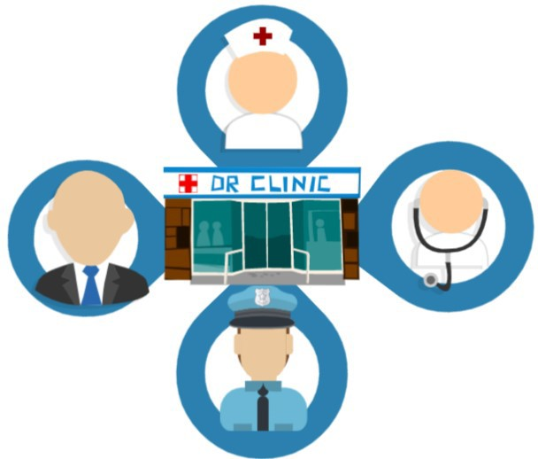
We will only ever use or share information with others if they are to be involved in your care and if it is important for your treatment. We will not give your information to anyone else without your permission unless there are exceptional circumstances or it is required by law.
We might share your information with other NHS organisations, schools, social services and sometimes the police. This is to make sure all the people who care for you know exactly who you are and what you need.

Where we can, we will try to ask you if it is ok to do this. There may be times when we need to share this information without asking, because we are not able to ask you and it is in your best interest or because it needs to be done quickly to help you.
The Practice must keep your personal
information and records private. The use and sharing of your information will be in line with the following laws and guidelines:
- UK General Data Protection Regulation ( UK GDPR) 2016
- Data Protection Act 2018
- Human Rights Act 1998
- Common Law Duty of Confidentiality
- NHS (Wales) Act 2006
- Health & Social Care (Wales) Act 2016
- Public Health (Wales) 2017

Every member of staff at the Practice must sign a confidentiality agreement and complete a training programme every other year to be able to learn how to keep information about you safe and private.
What are your rights?

You have the same data protection rights as an adult.

If you are unable to exercise your rights yourself, a parent may exercise them on your behalf. Generally, if you are 12 years old or older, we will ask that you exercise your own rights, or provide your consent for a parent to do this on your behalf.

